Lab Objective

Learn How to Use the Performance Monitor

**Lab Procedures**

**Step 1. Using Counters with Performance Monitor**

**1.** On Server01, open Server Manager.

**2.** On Server Manager, click Tools > Performance Monitor.

**3.** Browse to and click Monitoring Tools\Performance Monitor.

**4.** Click % Processor Time at the bottom of the screen. To remove the counter, click the Delete (red X) button at the top of the Window.

**5.** Click the Add (green plus (+) sign) button in the toolbar. The Add Counters dialog box appears.

**6.** Under Available counters, expand Processor, click % Processor Time, and click Show description, as shown in Figure 3-12. Read the description for % Processor Time.

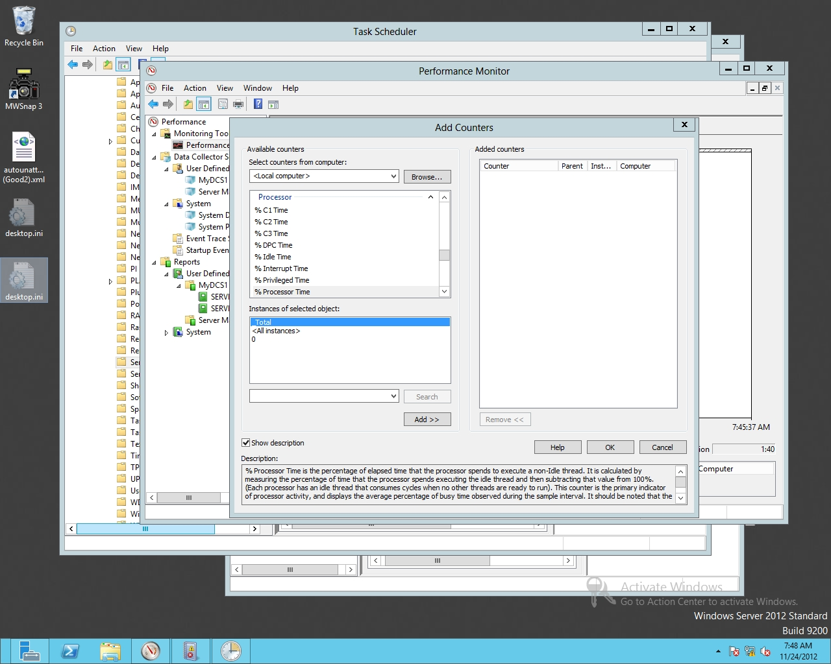

Figure 3-12

Looking at a description of a counter

**7.** Click Add. % Processor Time should show up in the Added counters section.

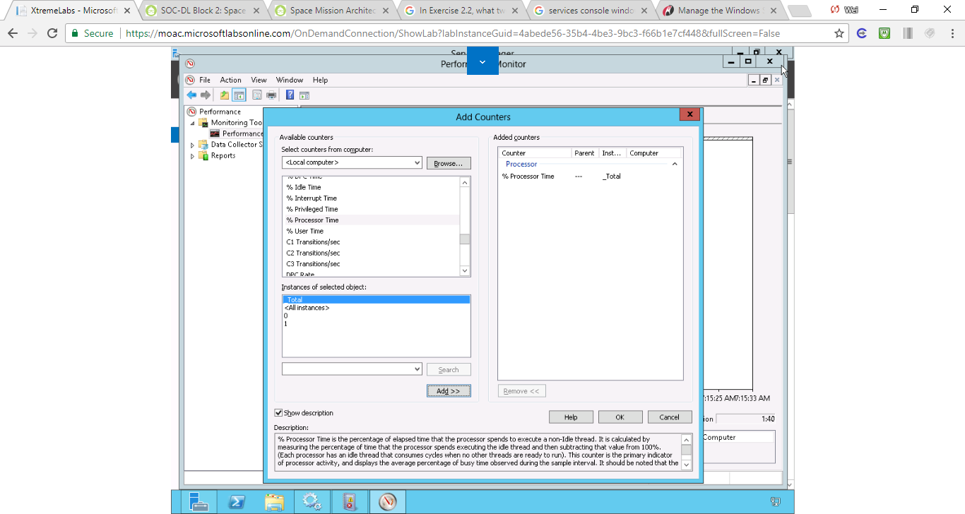

Figure . Step 7. Click Add. % Processor Time should show up in the Added counters section

**8.** Under Available Counters, expand the Server Work Queues and click the Queue Length counter. Under Instances of selected objects, click 0. Then click Add.

**9.** Add the following counters:

* System: Processor Queue Length
* Memory: Page Faults/Sec
* Memory: Pages/Sec
* PhysicalDisk (_Total): Current Disk Queue Length

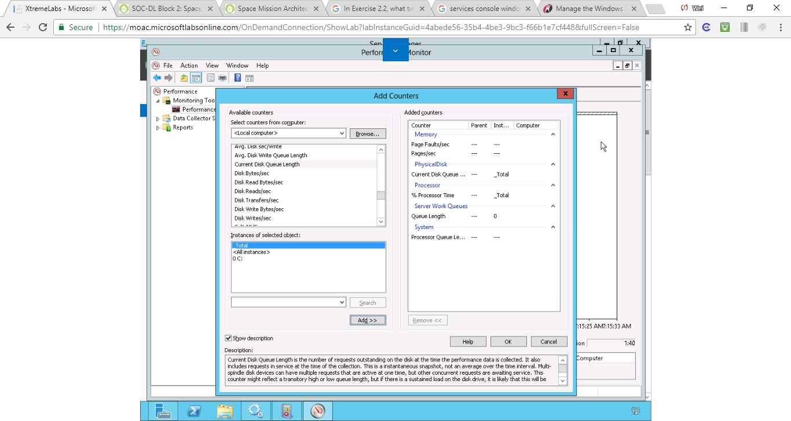

Figure Added counters

**10.** Click OK to close the Add Counters dialog box.

**11.** Open Task Manager, and close Task Manager. You should see a spike in CPU usage.

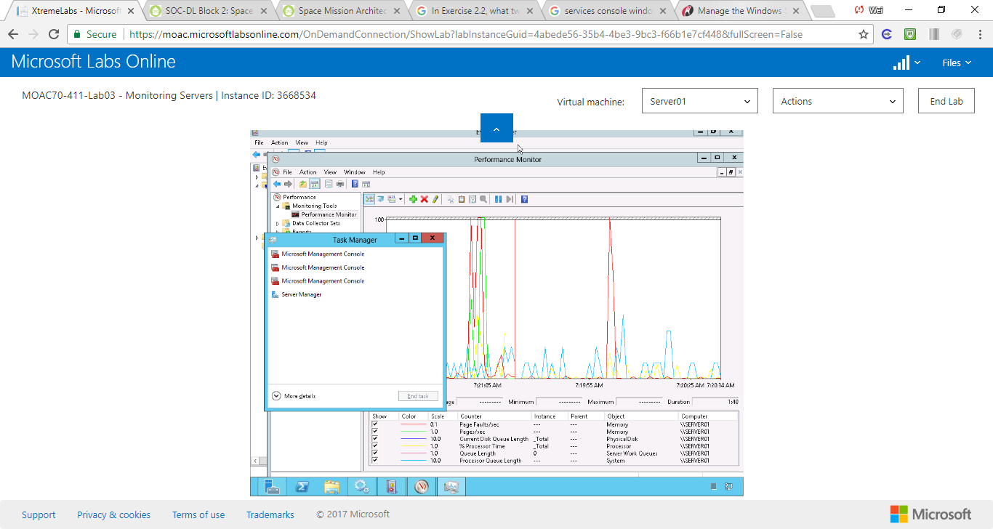

Figure . Step 11. Open Task Manager, and close Task Manager. There is a spike in CPU usage.

**12.** At the top of the graph, you see a toolbar with 13 buttons. Click the down arrow of the Change graph type (third button), and click Histogram bar.

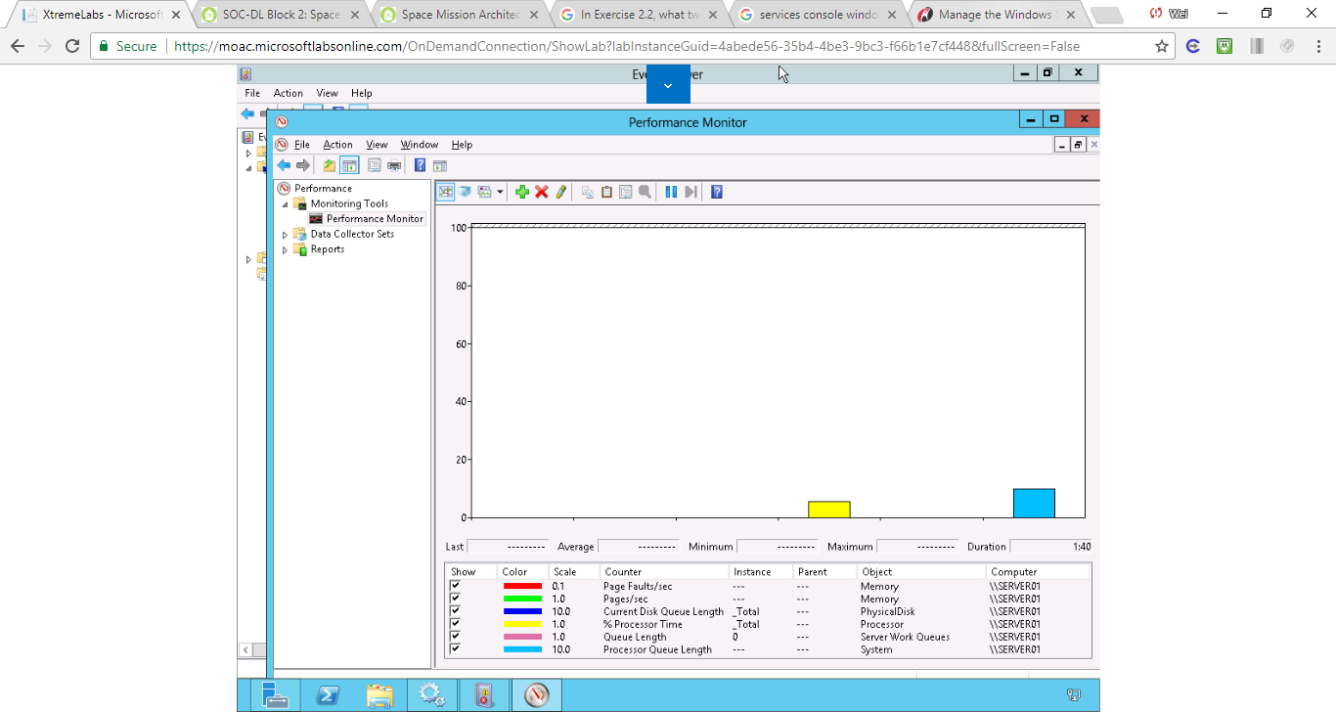

Figure Performance in Histogram

**13.** Change the graph type to Report.

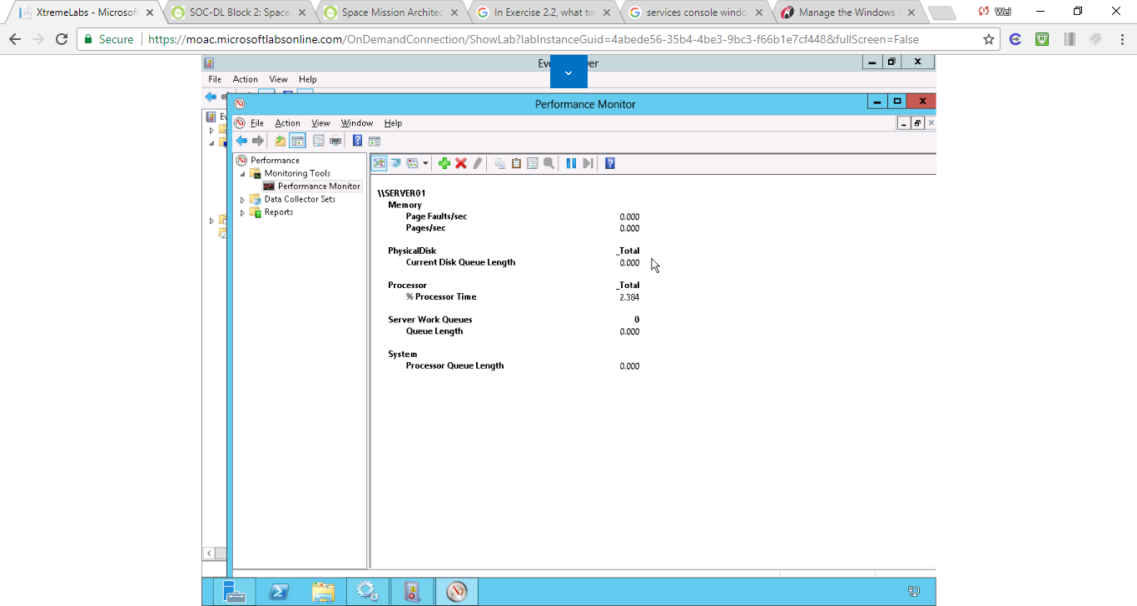

Figure Performance report

**14.** Change back to the Line graph.

**15.** Click the *Properties button (5th button from the end)* on the toolbar. The Performance Monitor Properties sheet appears. Notice the counters that you have selected.

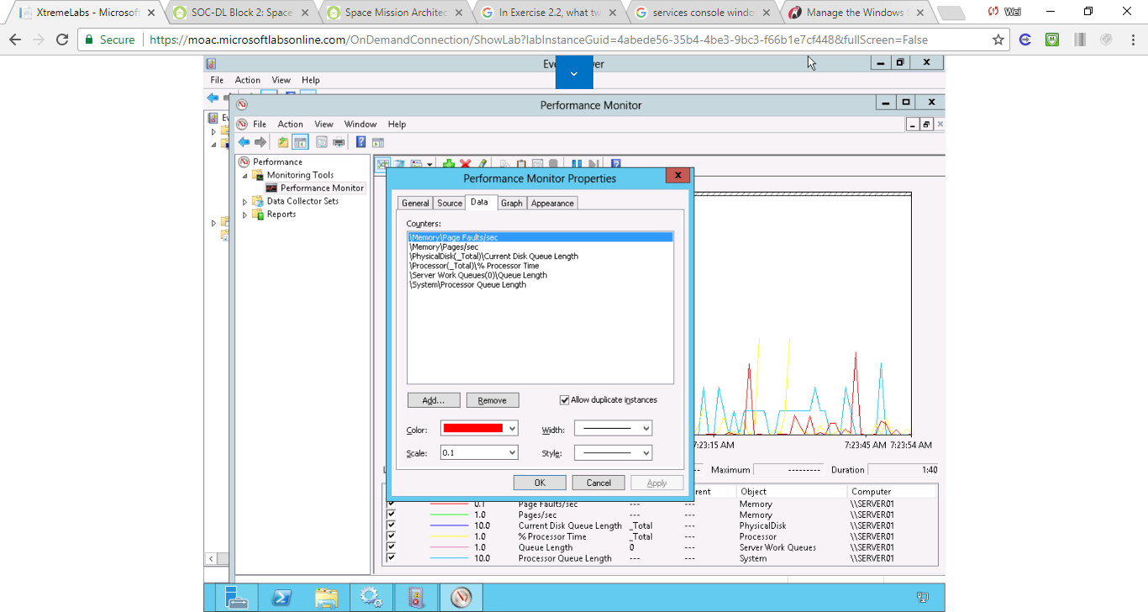

Figure . Step 15. Click the Properties button (5th button from the end) on the toolbar. The Performance Monitor Properties sheet appears. Notice the counters that you have selected.

**16.** Click *Processor (_Total)\%Processor Time*.

**17.** Change the width to heaviest line width. Change the color to Red.

**18.** Click the Graph tab.

**19.** In the Vertical scale box, change the value of the Maximum field to **200** and click OK.

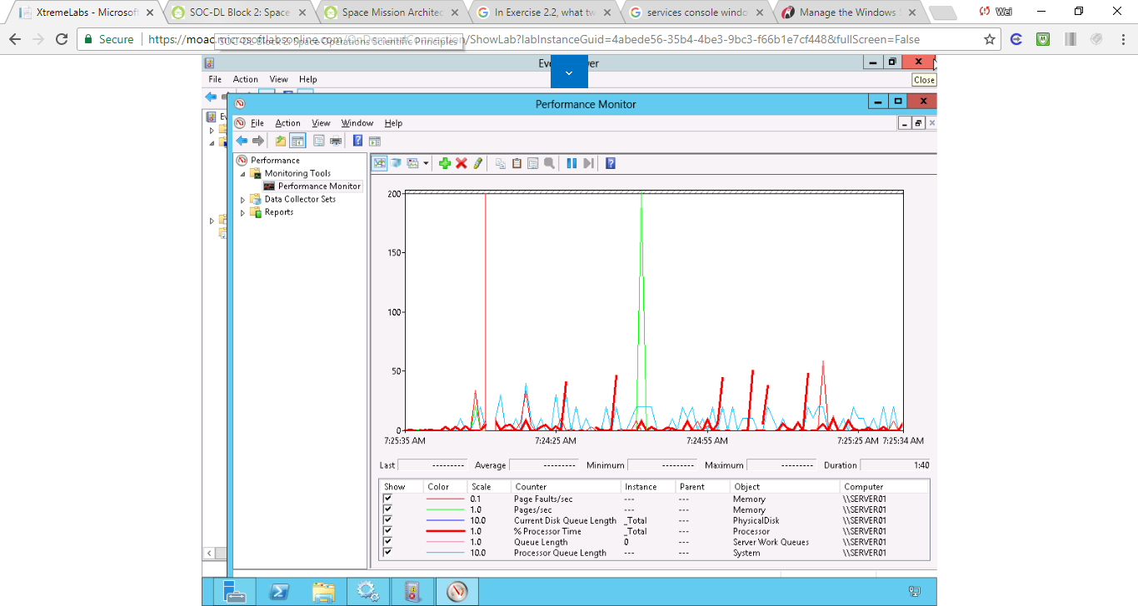

Figure . Step 17 - 19

**Step 2. Using DCS**

**1.** In the left pane, expand Data Collector Sets.

**2.** Right-click the User Defined folder, click New, and click Data Collector Set. Type **MyDCS1** in the Name: text box.

**3.** Click Create manually (Advanced) and click Next.

**4.** Select Performance Counter and then click Next.

**5.** To add counters, click Add.

**6.** Under Available Counters, expand the Processor node by clicking the down arrow next to Processor. Scroll down and click %Processor Time. Click Add.

**7.** Add the following counters.

* Server Work Queues: Queue Length counter
* System: Processor Queue Length
* Memory: Page Faults/Sec
* Memory: Pages/Sec
* PhysicalDisk (_Total): Current Disk Queue Length

**8.** Click OK, then Next.

**9.** Click Finish.

**10.** Right-click MyDCS1 and click Start.

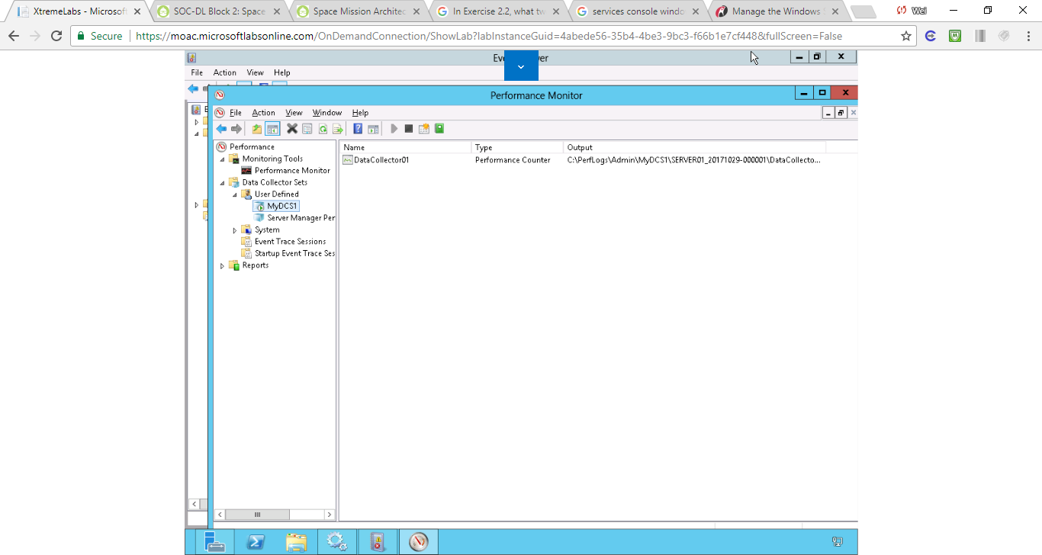

Figure . MyDCS1 outputs to c:\PerfLogs\Admin\MyDCS1

**11.** Let it run for at least two minutes.

**12.** Right-click MyDCS1 and click Stop.

**13.** Open File Explorer and navigate to c:\PerfLogs\Admin\MyDCS1. Then open the folder that was just created.

**14.** Double-click DataCollector01.blg. The Performance Monitor graph opens.

**15.** Take a screen shot of the Performance Monitor window by pressing Alt+Prt Scr and then paste it into your Lab03_worksheet file in the page provided by pressing Ctrl+V.

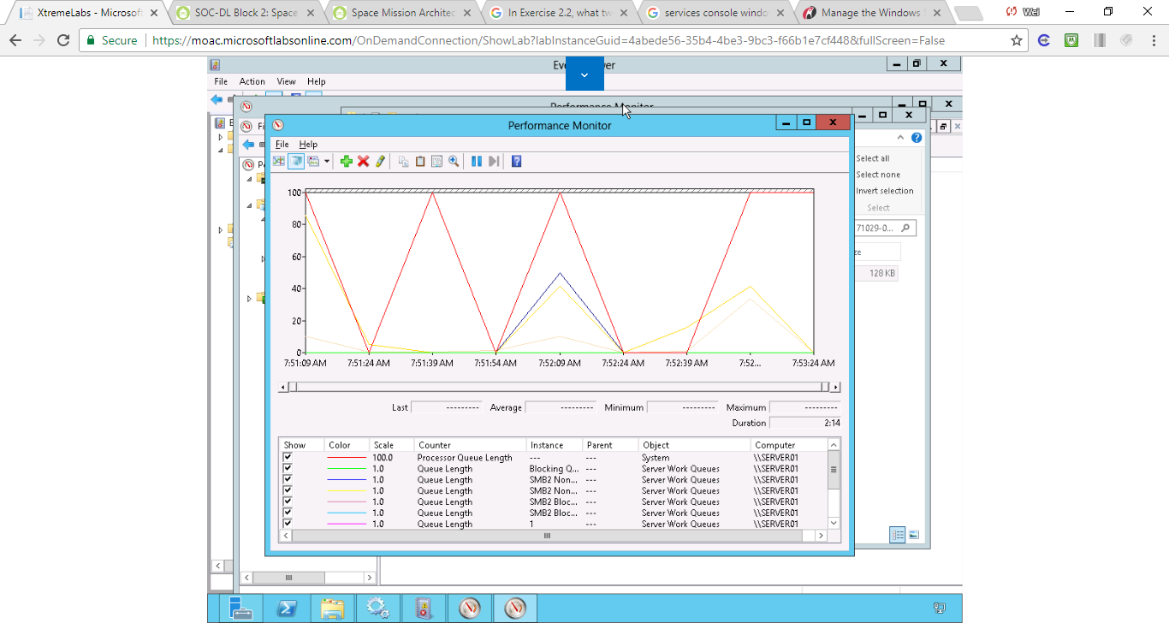

Figure MyDCS1 saves the monitored data in DataCollector01.blg.

**16.** Close the Performance Monitor graph and the MyDCS1 folder.

**17.** Close Performance Monitor.

**Lab Review Questions**

In Exercise 3.5, why did you want to create Data Collector Sets?

A Data Collector Set is the building block of performance monitoring and reporting in Windows Performance Monitor. It organizes multiple data collection points into a single component that can be used to review or log performance. A Data Collector Set can be created and then recorded individually, grouped with other Data Collector Set and incorporated into logs, viewed in Performance Monitor, configured to generate alerts when thresholds are reached, or used by other non-Microsoft applications. It can be associated with rules of scheduling for data collection at specific times. Windows Management Interface (WMI) tasks can be configured to run upon the completion of Data Collector Set collection.

**Lab Summary**

Although the Task Manager and Resource Manager gave me a quick look at my system performance, Performance Monitor allows me to thoroughly exam the performance of a system. During this exercise, I learned how to open Performance and show various counters over a period of time.